Set 8 – Employee Performance Analysis

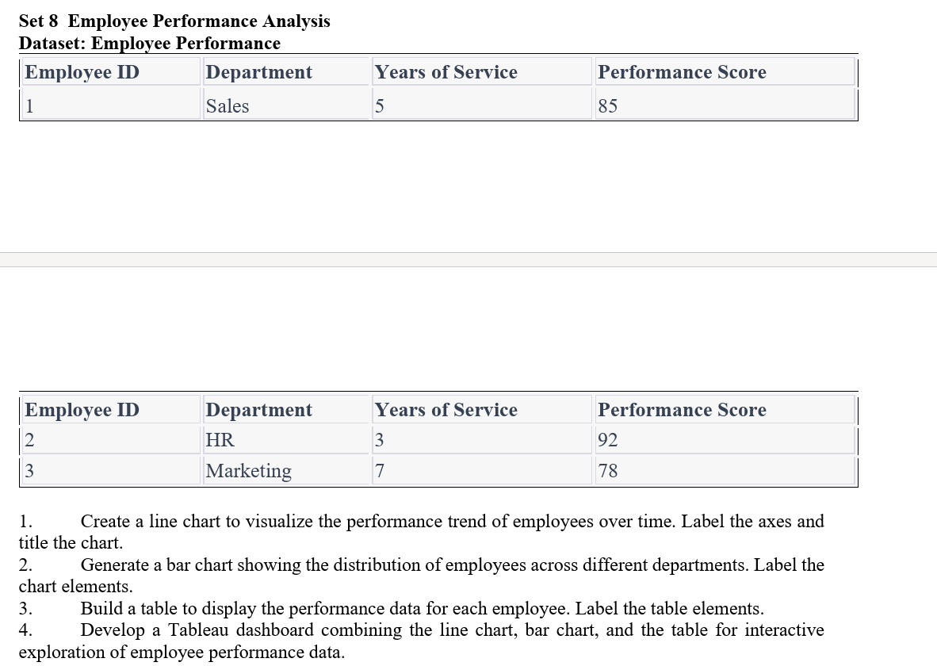

1. Line Chart
Aim:
To create a line chart to visualize the performance trend of employees over time.
Code:
# Employee Performance Data
employee_id <- c(1, 2, 3)
years <- c(5, 3, 7)
performance <- c(85, 92, 78)

# Line chart
plot(years, performance,
type = "o",
xlab = "Years of Service",
ylab = "Performance Score",
main = "Employee Performance Trend",
pch = 16)

# Add employee IDs
text(years, performance, labels = employee_id, pos = 3)
Output:
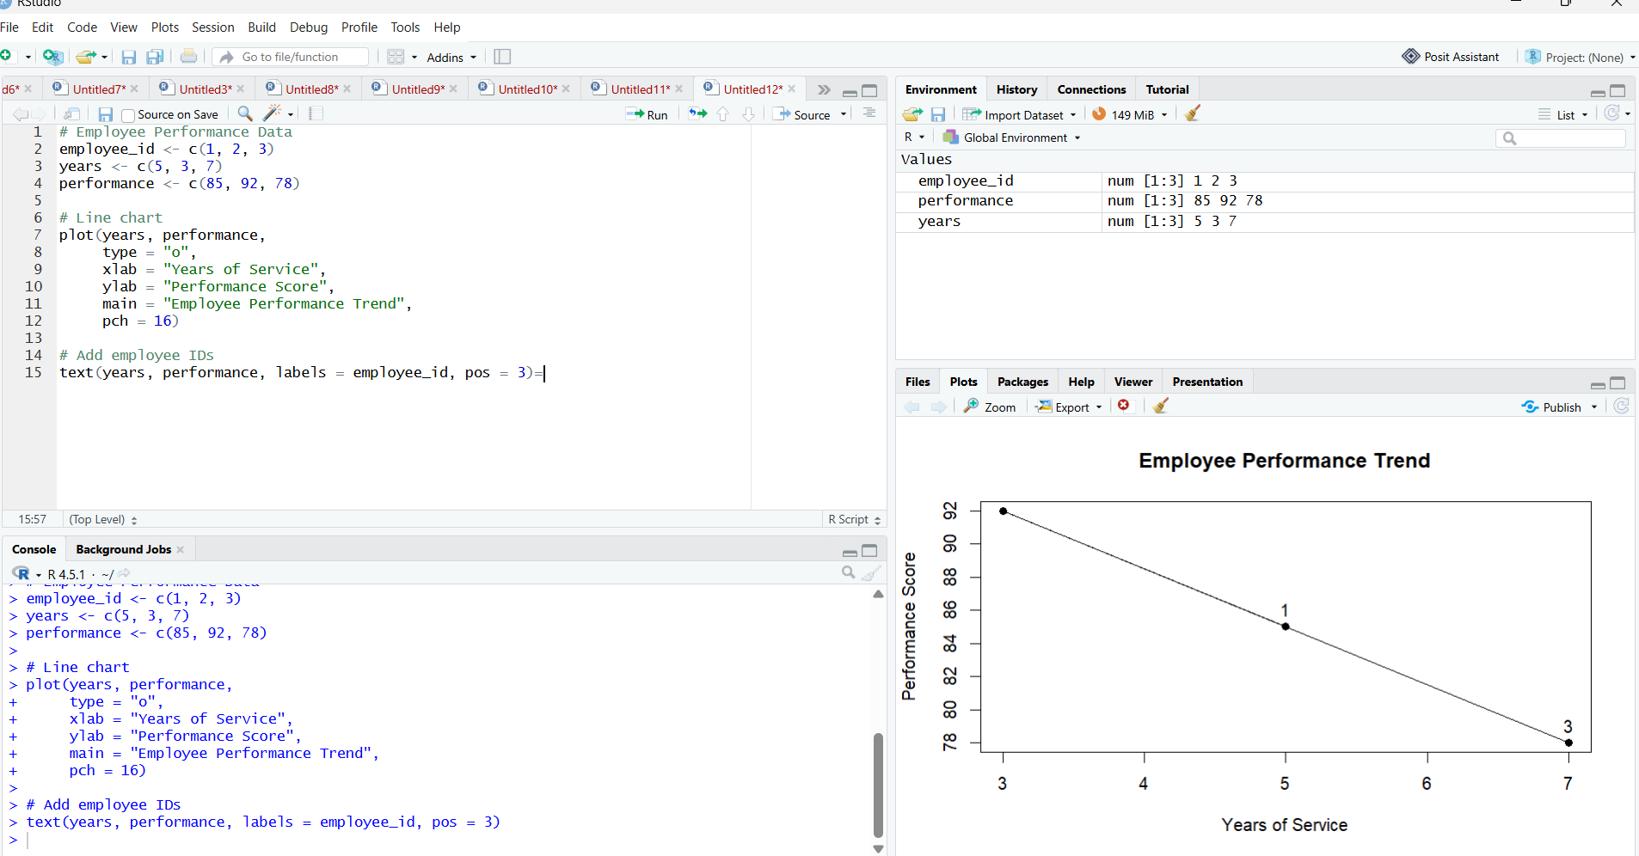

2. Bar Chart
Aim:
To create a bar chart showing the distribution of employees across different departments.
Code:
# Employee departments
department <- c("Sales", "HR", "Marketing")

# Count employees in each department
count <- table(department)

# Bar chart
barplot(count,
xlab = "Department",
ylab = "Number of Employees",
main = "Employee Distribution by Department",
col = "skyblue")
Output:
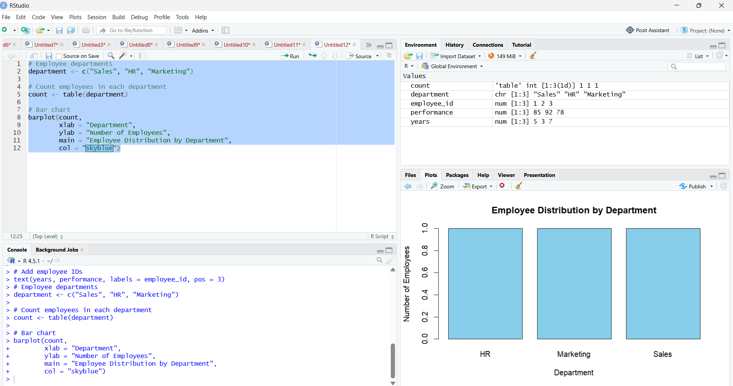

3. Table
Aim:
To create a table displaying the performance data of each employee.
Code:
# Employee Performance Data
employee <- data.frame(
Employee_ID = c(1, 2, 3),
Department = c("Sales", "HR", "Marketing"),
Years_of_Service = c(5, 3, 7),
Performance_Score = c(85, 92, 78)
)

# Display table
print(employee)
Output:
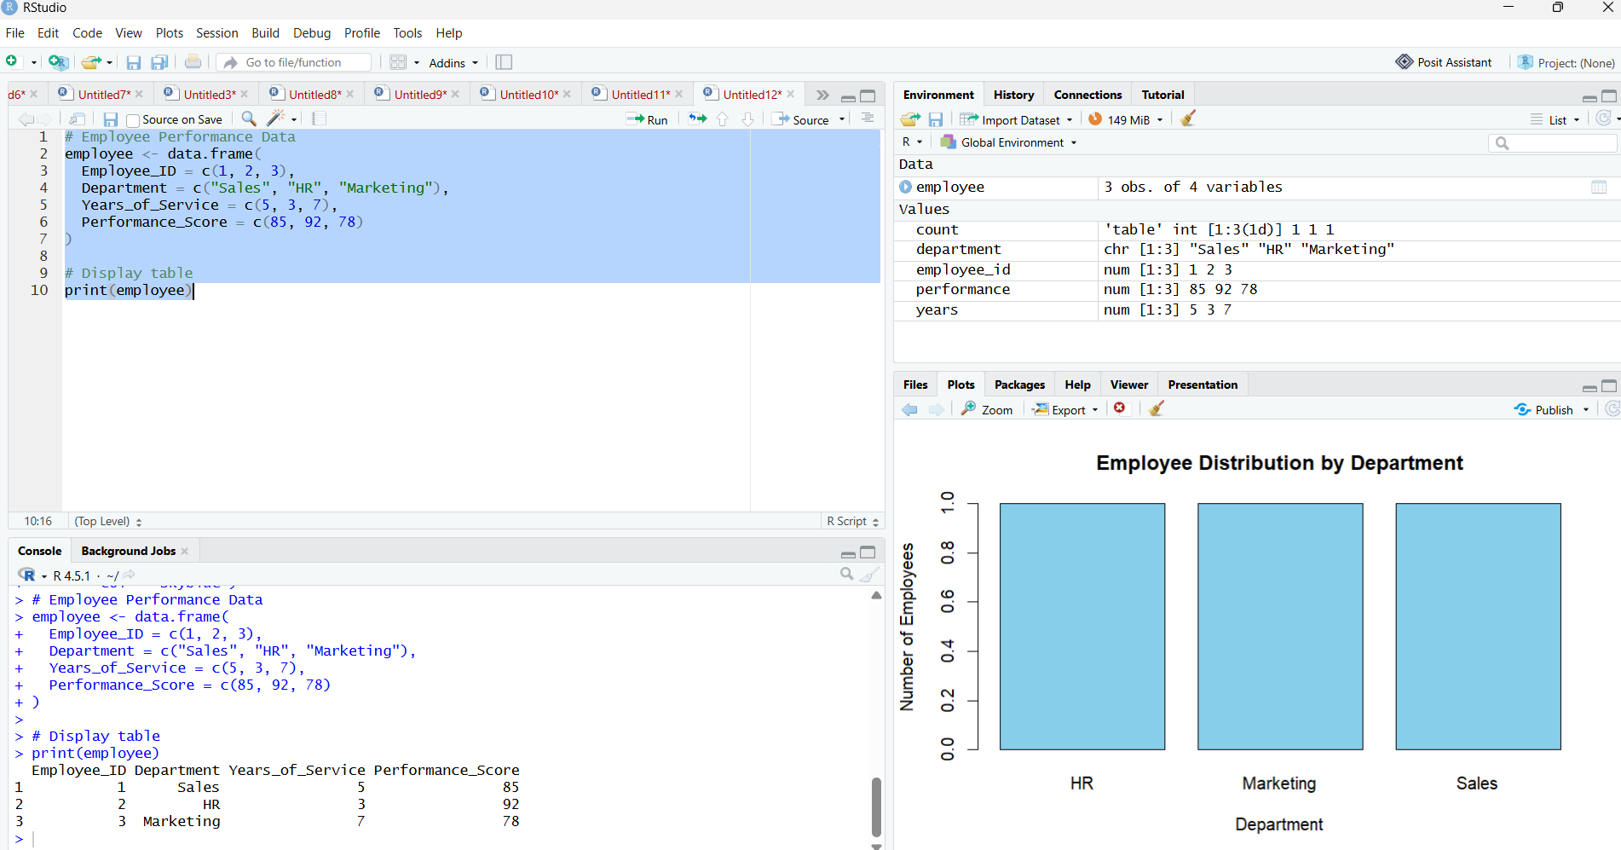

4. Tableau Dashboard
Aim:
To develop a Tableau dashboard combining the line chart, bar chart, and employee performance table for interactive analysis.

Output:
